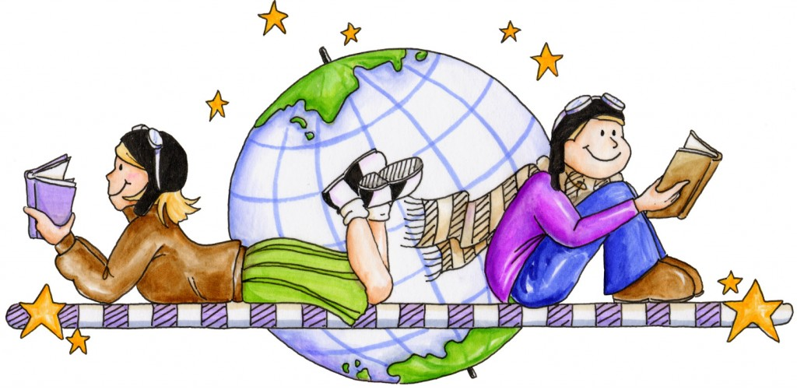

Homework week of June 5, 2017

- Your child is bringing French books to read at home each week.
Your child also needs to retell the story in French. Please fill in the passport sheet by including the title of the books your child has read and sign or initial on the line. The students are now working for an ice cream party. The two grade 3 FI classes together need to accumulate 35 stickers in order to partake in an ice cream party. (One filled passport sheet equals a big sticker.) We have already accumulated 25 stickers towards our ice cream party. Bravo!

- Practice multiplication tables 1, 2, 3, 4 and 5 at home this week.

IMPORTANT INFORMATION of

The end of the year report cards are approaching. I am in the process assessing your child’s reading and writing in French. Please continue to practice at home.

- Tuesday, June 6: Madam Charlotte Flores will come to teach lessons about agriculture in the classroom. Last week, the students weeded the garden beds so that we can plant in a couple of weeks (June 13, if weather permits.)

June 8: Parents are invited to come and see our Inquiry Project about seeds and plants in the classroom from 11:15-12:00. I hope to see you then.
June 9: The two grade 3 FI classes are going to the Nashwaak river in Marysville to see the trees they have planted, nature walk (bird watching) and critter dipping. Please dress appropriately as we are going rain or shine. (Bring rain boots and change of clothes.)
June 13, End of year field trip to Science East for the two grade 3FI classes.
The 2 grade 3FI classes are collecting donations of Art supplies for the children in the homeless shelter as our citizenship project. Please read sheet for more information. Thank you!
- June 23 is the last day of school. It will be a half day for students.
- June 20th is the family picnic from 11:45-1:00 pm.

We have also begun our science unit on plants and their changes. Here are some questions that you can practice at home. Quelles graines as-tu plantées dans la classe? Décris les graines. Qu’est-ce que tu as observé en regardant les

graines pousser? Est-ce que tes graines poussent? Quelles graines ne poussent pas? Quelle est ta graine préférée et pourquoi? Qu;est-ce qu’une plante? Nomme les parties d’une plante.

Your child should be able to answer basic routine questions and regarding the themes learned thus far. He /she needs to be able to recognize sounds and sight words. We will review the sight words learned thus far.
The students need to put into practice reading strategies that we have been working on. The students should be able to write independently a personal narrative by applying the strategies learned in class and referring to their visual dictionary and word wall. They need to use convention (proper use of punctuation and uppercase letters as well as write sight words correctly). We are reviewing the sounds learned thus far and going over how to write words with closer and correct spelling.

Math:

We will continue our unit measurement (weight g/kg) and our unit on patterns.

In English class, we will continue to learn about citizenship and government (provincial, municipal and First Nations). The students will be writing a personal narrative.

